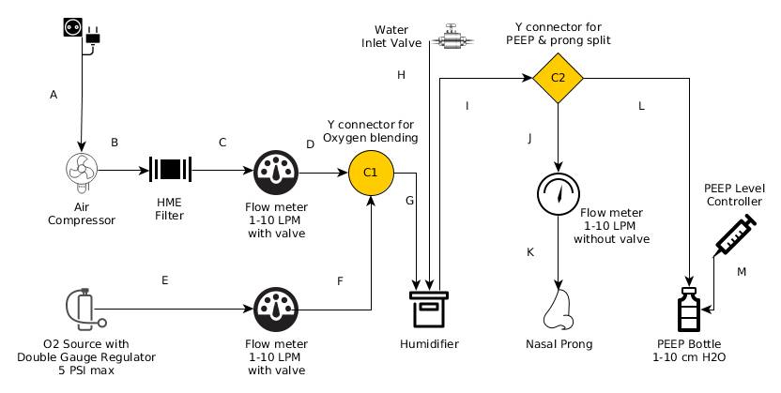

Water Inlet Valve

Y connector for PEEP & prong split

C2

Y connector for Oxygen blending

*сі*

PEEP Level Controller

Air Compressor

**HME Filter**

**Flow meter**

**1-10 LPM with valve**

**Flow meter**

1-10 LPM without valve

>6

Humidifier

Nasal Prong

02 Source with Double Gauge Regulator

5 PSI max

**Flow meter**

1-10 LPM with valve

PEEP Bottle 1-10 cm H2O